Kubernetes Task-2
Task Description:
Create the K8s EKS further you have to do the deployment of the Nginx application and access the application outside the cluster.
Steps: -
- Install AWS in local machine by using AWS CLI: -
Before install AWS in local machine check the AWS Version using the below command,
Command is aws --version
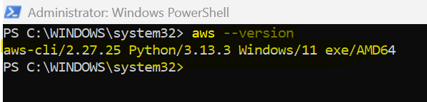

  - If you are not installed AWS CLI in local machine follow the below steps to install AWS CLI in local machine.
Install or update the AWS CLI
To update your current installation of AWS CLI on Windows, download a new installer each time you update to overwrite previous versions. AWS CLI is updated regularly. To see when the latest version was released, see the AWS CLI version 2 Changelog on GitHub.
- Download and run the AWS CLI MSI installer for Windows (64-bit):
https://awscli.amazonaws.com/AWSCLIV2.msi
Alternatively, you can run the msiexec command to run the MSI installer.
C:\> msiexec.exe /i https://awscli.amazonaws.com/AWSCLIV2.msi

For various parameters that can be used with msiexec, see msiexec on the Microsoft Docs website. For example, you can use the /qn flag for a silent installation.
C:\> msiexec.exe /i https://awscli.amazonaws.com/AWSCLIV2.msi /qn

- To confirm the installation, open the Start menu, search for cmd to open a command prompt window, and at the command prompt use the aws --version command.
C:\> aws --version
aws-cli/2.19.1 Python/3.11.6 Windows/10 exe/AMD64 prompt/off

- If Windows is unable to find the program, you might need to close and reopen the command prompt window to refresh the path, or follow the troubleshooting in Troubleshooting errors for the AWS CLI.

- Configure AWS: -
Enter command to configure AWS in local machine is aws configure
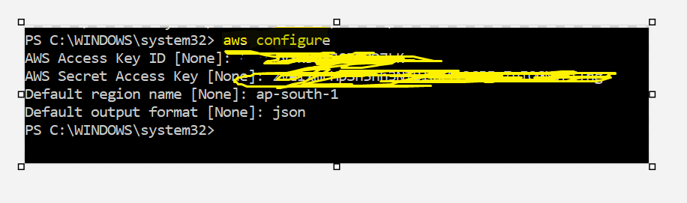

- Create EKS with AWS CLI Command: -
To communicate with EKSCTL is choco install eksctl -y
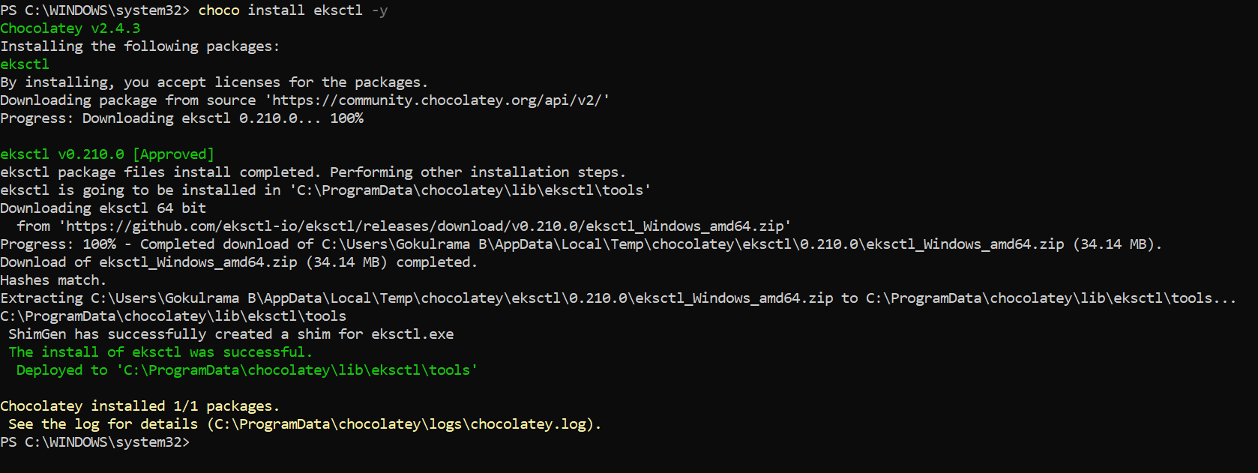

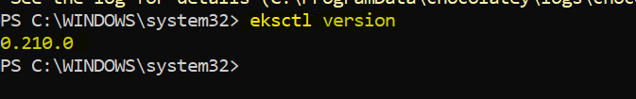

Download AWS IAM Authenticator,
To authenticate with EKS is choco install aws-iam-authenticator -y
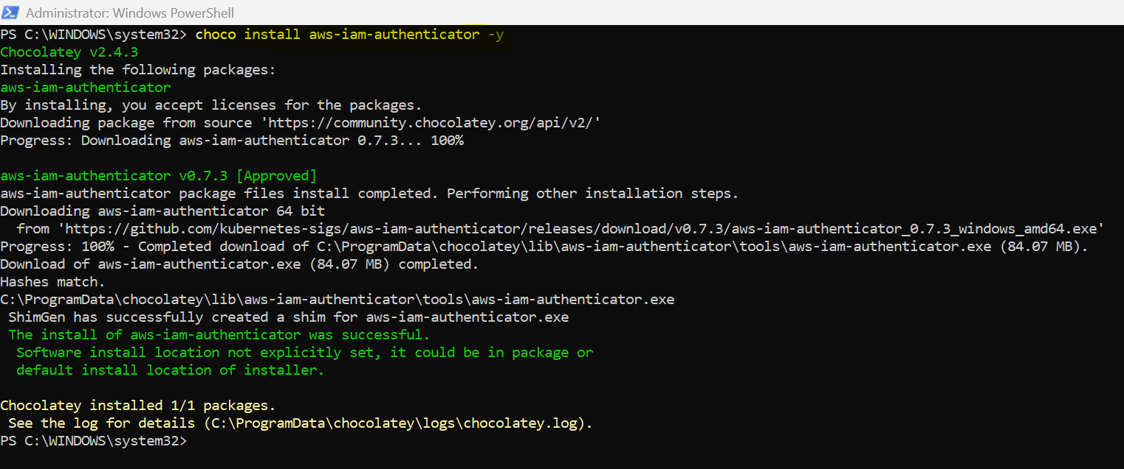

Creating cluster,
eksctl create cluster --name cluster1 --region ap-south-1 --nodegroup-name nodegroup1 --node-type t3.medium --nodes 1
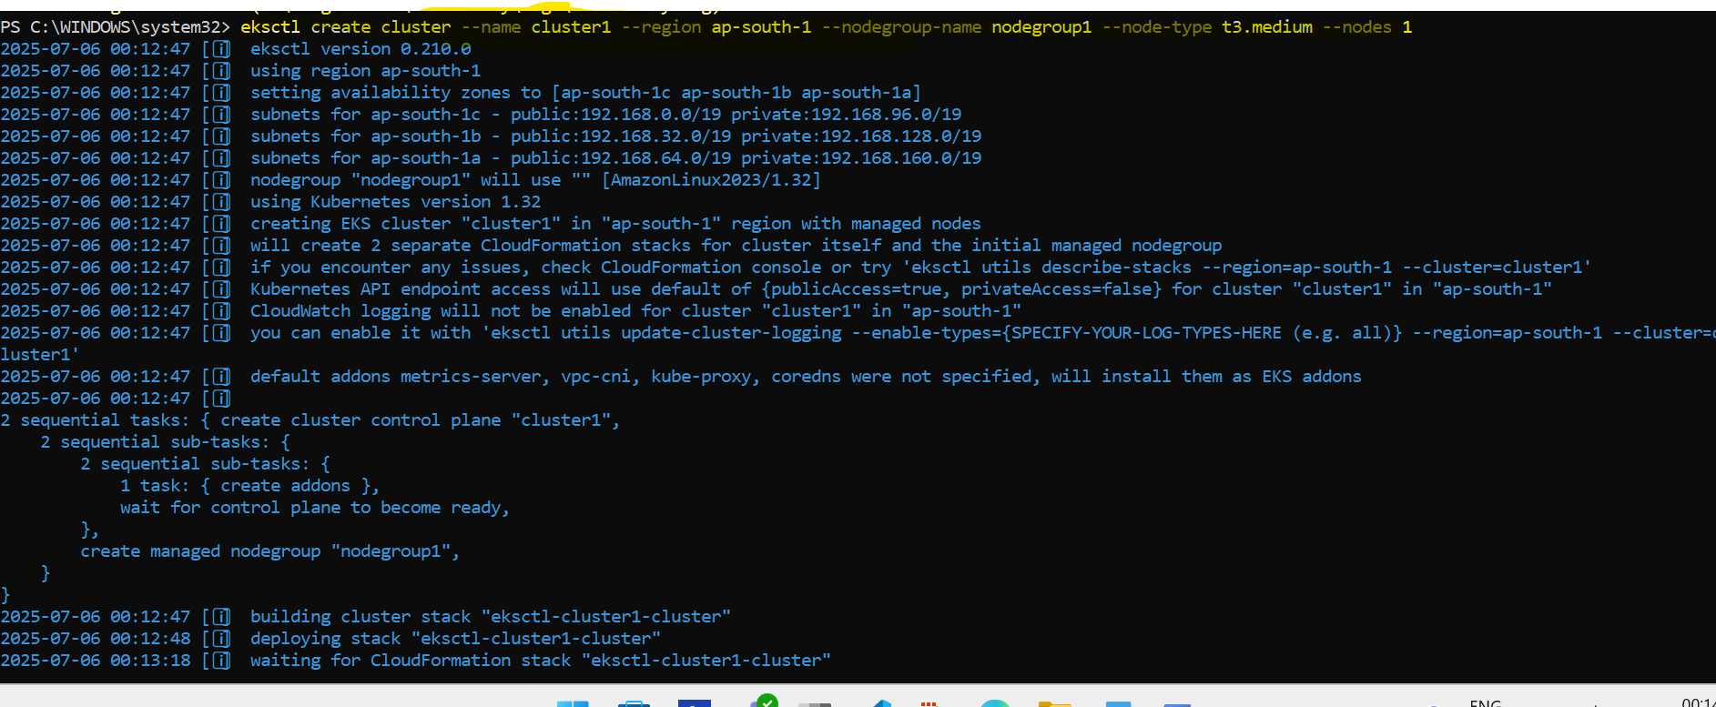
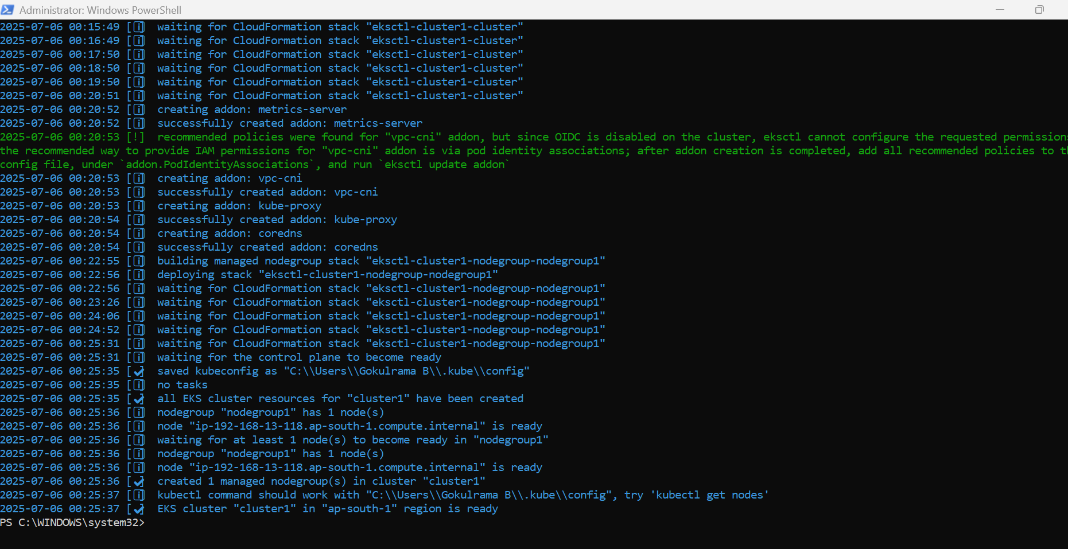

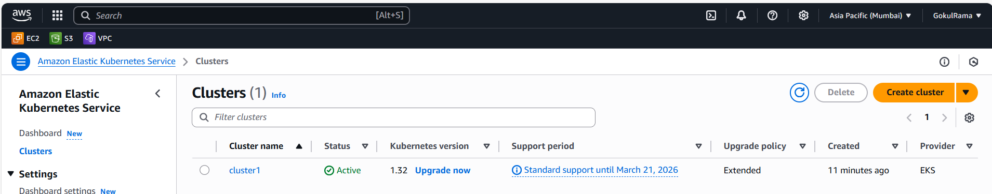

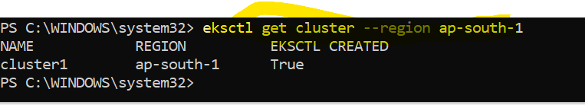

To update Kubeconfig,
aws eks update-kubeconfig --region ap-south-1 --name cluster1

Verification of nodes,
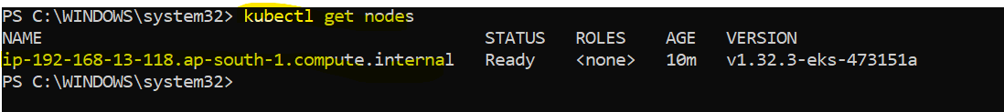

EC2:
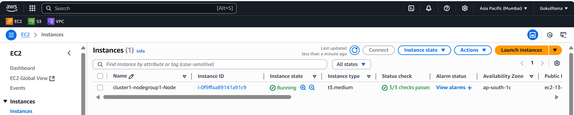

- Deployment of the Nginx application: -
kubectl create deployment nginx --image=nginx
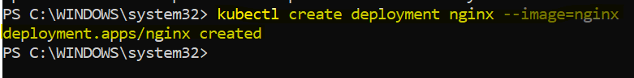

kubectl expose deployment nginx --type=LoadBalancer --port=80
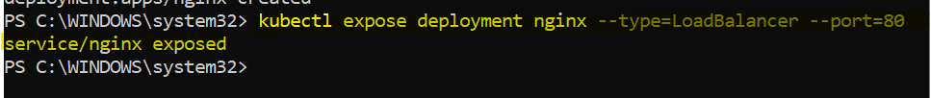

kubectl get svc
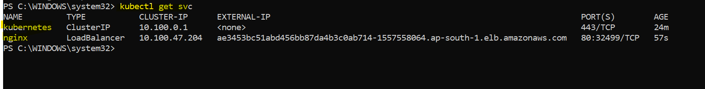

- Access the application outside the cluster:
Hit the load balancer domain address get the NGINX page.

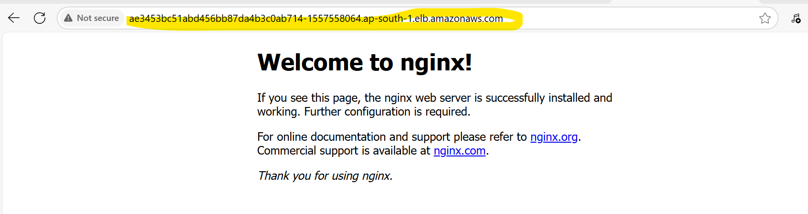

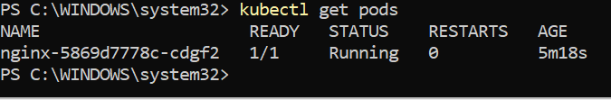

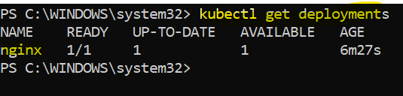
=============================================================

Delete the cluster,
eksctl delete cluster --name cluster1 --region ap-south-1
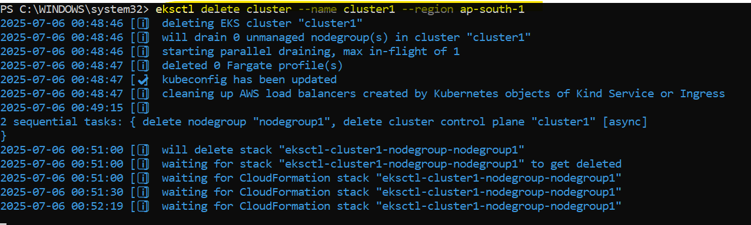
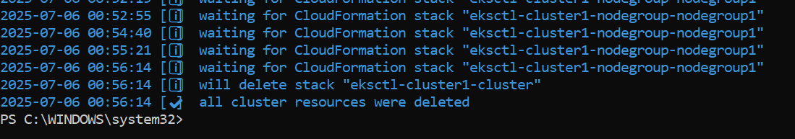

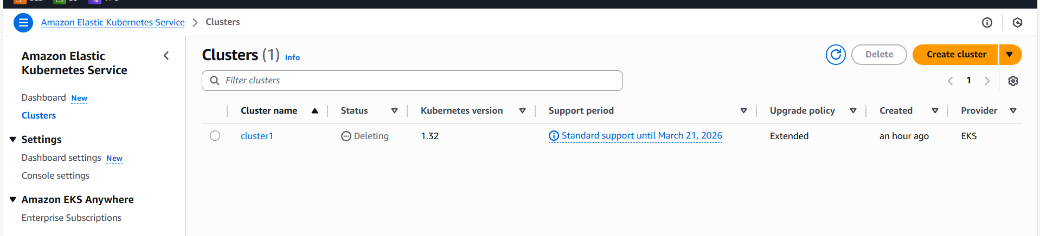

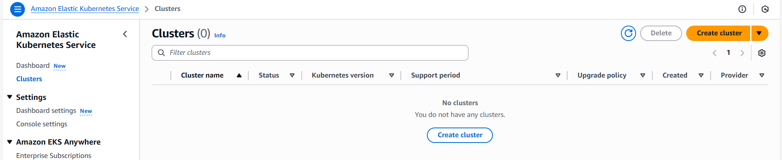

Finally terminate EC2 instance manually

